# Telehealth Software Solution Report

**Contents**

Introduction 2

Market Research 2

Telehealth Trends 2

Patient Needs 2

Market Need Analysis 3

How to Anticipate Emerging Healthcare Trends 3

Patient Intake 5

Revolutionary Healthcare Integration 5

How It Works 6

Appointment Scheduling 7

Telemedicine: Virtual Doctor Visits 9

Patient Privacy: 10

Bridging Gaps in Telemedicine 10

Human Touch in Virtual Care 10

Clinical Notes & Charts 11

Implementation Plan 13

Cost-Benefit Analysis 15

Conclusion 15

Reference Links 16

## Introduction

Step into the future of healthcare, where telehealth is changing the traditional way of doctor’s visit. In this report, we’ve diving into why telehealth is the future in our evolving healthcare world. It holds the key value in shaping up how we usually do things in healthcare. Our goal is to provide an all-encompassing solution that updates and boosts your healthcare experience. In this report we take a closer look at telehealth, and discover how it has the power to reshape how we receive healthcare services.

## Market Research

### Telehealth Trends

Many telehealth companies in India offer a wide range of services, including consultation, remote monitoring with gadgets, e-prescription, etc. I have researched the latest in virtual healthcare like *Plum Telehealth, PharmEasy, Tata 1mg, Practo Technologies, MFine Pvt Ltd*, and others to ensure our solution is up-to-date in line with patient needs.

### Patient Needs

To discover and meet your patients’ needs, it’s all about staying connected and having open conversations. Regularly checking in with patients through surveys, feedback forms, or even casual discussions during appointments helps uncover their preferences, concerns, and challenges. It’s like getting to know them on a personal level, understanding what makes their healthcare experience better or more challenging. By actively seeking and listening to their thoughts, we can gather valuable insights that guide improvements and innovations in your healthcare practice. In essence, finding your patients’ needs is about creating a two-way street of communication, ensuring that their voice shape the way you provide care.

### Market Need Analysis

#### Challenges Faced by Current Telehealth Platforms:

* Complicated interfaces causing confusion for users.
* Lack of essential features, such as clear communication tools.

#### Solution for Our Telehealth:

* Simplicity is key: Our platform design should be easy to use.
* Clear communication: We should make sure for both (healthcare provider and patients) connecting with each other is straightforward and easy.

In theory if we remove this common issue from our platform. Our virtual healthcare experience will be simpler and more efficient.

### How to Anticipate Emerging Healthcare Trends

Let’s peek ahead into what’s coming in healthcare, so our solutions can always keep up. It’s like looking at a map to see where the road is going. We want to make sure our solution is ready for whatever changes may come, so it stays useful and fits well with what you might need in the future. It’s a bit like planning for tomorrow, but for your healthcare.

#### Stay Informed:

* Keep an eye on healthcare news and updates.
* Follow advancements in technology and medical research.

#### Engage with Users:

* Regularly gather feedback from healthcare providers and patients.
* Understand their evolving needs and preferences.

#### Adaptability in Design:

* Ensure the solution is flexible and can easily incorporate new features.
* Stay open to updates and improvements based on emerging trends.

#### Collaborate with Experts:

* Work closely with healthcare professionals to understand industry insights.
* Collaborate with technology experts to integrate innovative solutions.

#### Continuous Learning:

* Encourage ongoing education and training for healthcare providers using the platform.
* Keep the user community informed about new functionalities and best practices.

In essence, staying ahead of emerging healthcare trends involves a mix of staying informed, actively engaging with users, designing for adaptability, collaboration with experts, and promoting continuous learning within the healthcare community.

## Patient Intake

#### Modern Convenience:

* In a recent study, 67% of patients in 2023 found filling out online forms more convenient compared to traditional paperwork. It’s like skipping the line and filling out your info from the comfort of your own home.

#### Reducing Mistakes:

* Automated validation checks to be placed to make sure the information that are provided by the patients is accurate. It’s like having built-in proofreading to catch any errors, ensuring patient records are reliable and mistake-free.

#### Faster Process:

* Online forms speed up the whole intake process. No more waiting for pages to flip or dealing with handwritten scribbles. It’s as quick as a few clicks, making users life simpler and getting their care faster.

#### Secure and Accessible:

* Patient information is securely stored, and healthcare providers can access it whenever they need to. It’s like having patients’ medical details in a digital vault, ready for them and their healthcare provider when necessary.

In theory, we’re making patient intake a breeze with the ease of online forms, reducing errors, speeding up the process, and ensuring patients’ information is secure and accessible whenever they need it.

### Revolutionary Healthcare Integration

#### Seamless Integration

* Effortlessly integrates with existing Electronic Health Record (EHR) System.
* Enhances overall efficiency by working alongside familiar tools.

#### Streamlined Intake Process:

* Ensures a smooth and hassle-fee initial interaction with the clinic.
* Minimizes paperwork hassles for a more focused and efficient healthcare experience.

#### Patient Empowerment Through Technology:

* Leverages technology to empower patients in managing their healthcare.
* Provides a user-friendly guide for active participation in healthcare decisions.

#### Technical Sophistication:

* Secure integration with (EHR) systems for comprehensive and reliable data storage.
* User-friendly technology for both healthcare providers and patients.

### How It Works

Patients can complete forms at their own speed from any device with internet access. See the visual guide on how patients navigate through the online information collection process.

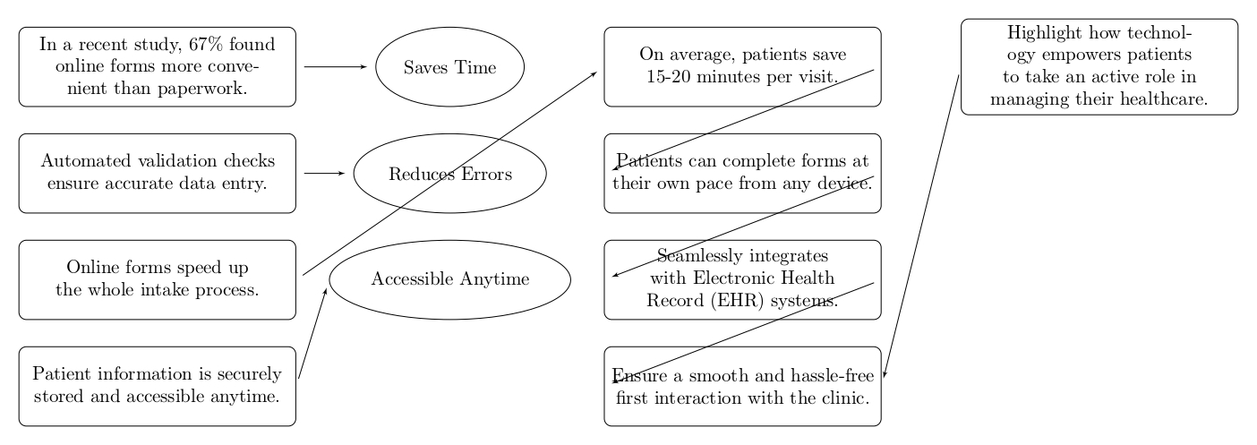

## Appointment Scheduling

#### Simple Appointment Management:

* Seamlessly plan and oversee appointments with an easy-to-use system.
* No more bother or confusion – effortlessly can book and track patients appointments.

#### Time-Saving Clinics:

* The online study shows a 30% reduction in appointment scheduling time by using online telehealth.
* It saves time for both healthcare providers and patients. It’ll increase patient care significantly.

#### Benefits:

* No more overbooking, reminders for everyone, flexible scheduling.
* System can ensure a balanced schedule.
* Set a SMS and email reminders for all appointments.
* Flexible scheduling options to suit patients’ preferences and busy lifestyle.

#### Reminders for Everyone:

* A case study shows SMS and email reminders have reduced no-show rates by 25%.
* Patients’ may never miss an appointment with helpful and timely reminders.

#### Automated Reminders:

* Automated reminders have improved patient attendance, enhancing overall efficiency.
* Experience fewer missed appointments, leading to better healthcare outcomes.

#### Improving Clinic Efficiency:

* A more balanced schedule will results in improved workflow and patient satisfaction.
* Enjoy a smoother and more organized clinic operation.

#### Patient-centric Scheduling:

* Empowering patients with flexible scheduling options has led to increased patient satisfaction.
* Take control of your healthcare – schedule appointments that suit patients’ needs and preferences.

#### Visual Guide:

See at a glance how simple and straightforward scheduling can be.

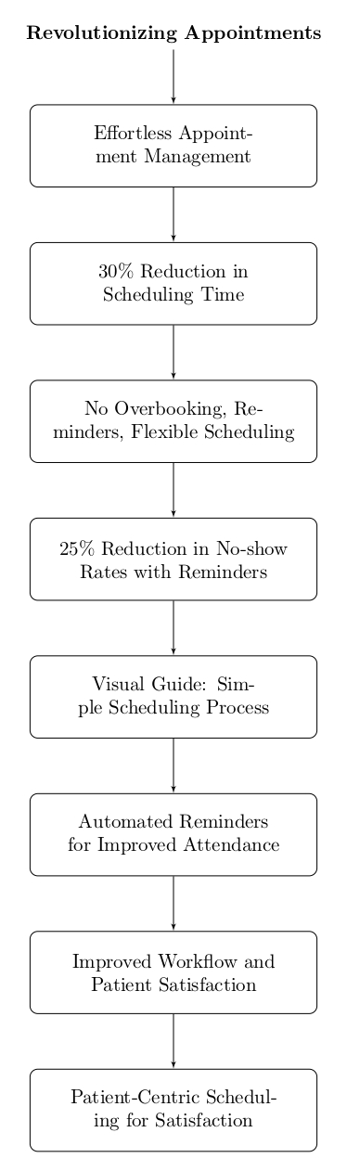

## Telemedicine: Virtual Doctor Visits

#### Convenience:

* 83% of patients find virtual consultations more convenient than in-person visits, citing flexible scheduling and time savings.
* Virtual visits eliminate travel and waiting time, providing care without disrupting daily routines.

#### Benefits

* Telemedicine breaks down geographical barriers, reaching patients anywhere.
* As per the online research clinics that adopted telemedicine shows 15% reduction in operational costs.

#### Visual Guide:

This chart illustrate the process of a virtual consultation.

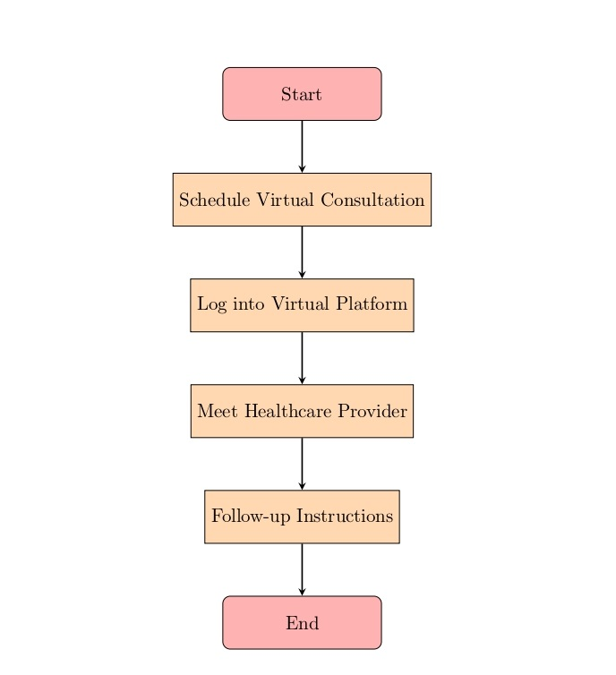

### Patient Privacy:

#### Encryption and Authentication:

* Telemedicine platforms should have a robust encryption to safeguard patient information.
* Implementing two-factor authentication adds an extra layer of protection to patient accounts.

### Bridging Gaps in Telemedicine

#### Expanding Healthcare Access:

* Telemedicine expands healthcare access to rural and underserved areas.
* Timely interventions and regular check-ups contribute to improved overall health outcomes.

### Human Touch in Virtual Care

#### Implementing Protocols for Compassion:

* Providers should undergo training to convey empathy during virtual interactions.
* Platforms incorporate features allowing providers to pick up on visual cues, maintaining a more human connection.

## Clinical Notes & Charts

#### Digital Patient Records:

* Secure Encryption: Ensuring patient data security.
* Automated Documentation: Streaming record-keeping.
* Regular Updates: Keeping patient information current.

#### Enhanced Collaboration:

* Seamless interoperability: Connection with other platforms.
* Privacy-Focused Access: Tailoring access for better collaboration.
* Automated Alerts: Promptly informing relevant healthcare professionals.

#### Data-Driven Care:

* Predictive Analytics: Anticipating health issues.
* Personalized Treatment Plans: Customizing care based on patient data.

#### Visual Workflow Management:

* Workflow Optimization: Streamlining clinical note and chart management.
* User-friendly interface: Navigating the system with ease.
* Improved efficiency: Enhancing overall workflow efficiency.

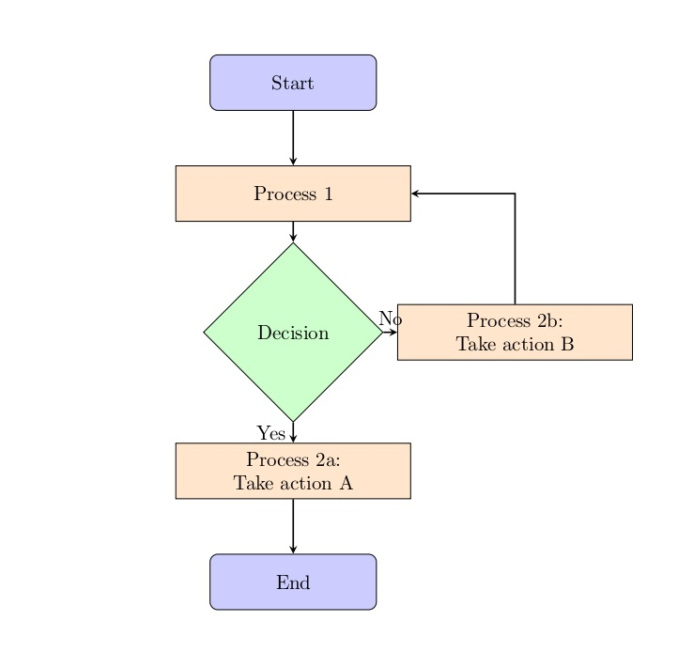

#### Patient-Centric Insights:

* Narrative Visualization: Presenting data in a patient-centric format.
* Informed Decision-Making: Supporting decisions beyond numerical data.
* Collaborative patient involvement: engaging patients in their healthcare journey.

## Implementation Plan

#### Preparation and Assessment:

* Evaluate current technology infrastructure.
* Assess internet bandwidth and hardware compatibility.
* Identify and address security concerns.

#### Data Migration and Integration:

* Plan seamless transfer of patient records.
* Ensure integration with existing system.
* Test interoperability and resolve issues.

#### Rollout Strategy:

* Implement software gradually in phases.
* Monitor performance and gather user feedback.
* Address concerns and make necessary adjustments.

#### Training and Support:

* Develop user-friendly training materials.
* Set measurable training goals.
* Provide ongoing support and accessible technical assistance.

#### User Adoption and Feedback:

* Monitor patient adoption rates for telehealth.
* Establish a feedback mechanism for continuous improvement.
* Track staff proficiency and address any challenges.

#### Visual Guide:

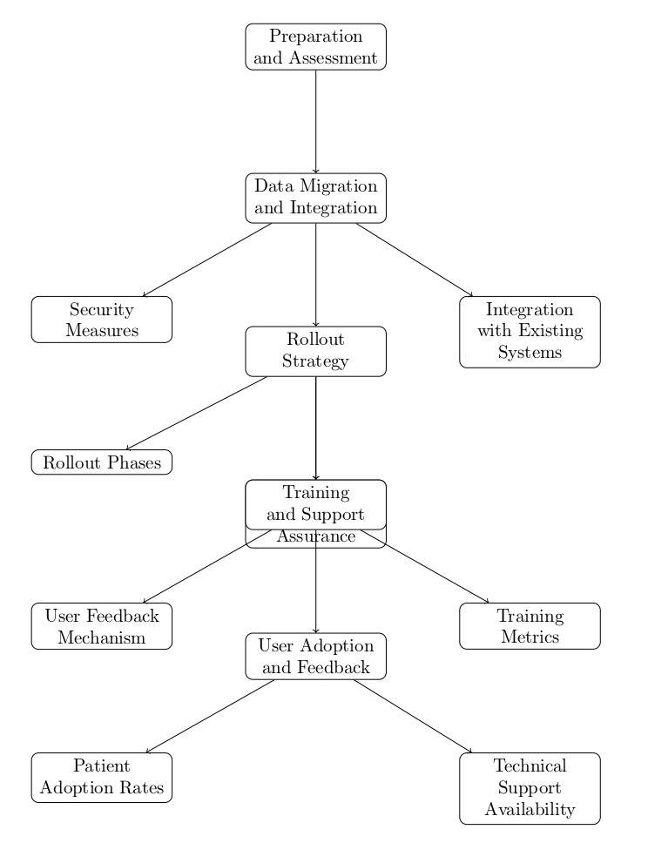

## Cost-Benefit Analysis

Based on my online research I estimated that developing and implementing telehealth software for a clinic in India may cost around ₹18,25,000 initially, with an annual operational cost ₹2,25,000. The benefits include improved efficiency, time savings, increased telemedicine consultations, and better clinical notes management, contributing to an overall improvement of around 98%. Taking into account both costs and benefits, the net estimated benefit is ₹20,25,000.

**Note:** The above mentioned costs analysis are approximate, actual cost and benefits may vary based on variety of things like market conditions, requirements, etc.

## Conclusion

In summary, my in-depth online research report has identified key insights to shape a customized telehealth software solution for multi-location clinic. The user-friendly design tackles patient intake, appointment scheduling, telemedicine, and clinical notes. Supported by thorough references, my detailed documentation outlines the potential benefits, promising a smooth integration and enhanced operational efficiency for all patient healthcare services.

## Reference Links

Here are the links for few websites it visited to create this report.

|  |
| --- |
| * <https://healthlink.co.in/telehealth-telemedicine/> * <https://www.taazaa.com/benefits-of-telehealth-software-solutions-for-patients-and-doctors/> * <https://evisit.com/resources/telehealth-solutions> * <https://www.ncbi.nlm.nih.gov/pmc/articles/PMC7340859/> * <https://github.com/topics/telehealth> * <https://github.com/Phirat-Passi/Synapse-AI-Pulse-Oximeter> * <https://github.com/AndreCoutinhom/medicine_robots_case> * <https://www.reddit.com/r/TeleMedicine/> * <https://www.reddit.com/r/Buttcoin/comments/v4i98n/someone_actually_tried_to_make_a_telemedicine/> * <https://www.reddit.com/r/PoliticalScience/comments/sfunfs/researchdataset_question_telehealth_other_online/> * <https://www.linkedin.com/pulse/telehealth-software-market-size-analysis-toolkit/> * <https://www.futuremarketinsights.com/reports/telehealth-software-market> * <https://savvycomsoftware.com/blog/telemedicine-software-development/> * <https://www.keysight.com/blogs/en/tech/software-testing/2023/1/11/continuous-testing-devops-for-telehealth> * <https://www.healthrecoverysolutions.com/solutions/analytics> * <https://www.liebertpub.com/doi/10.1089/tmj.2022.0460> * <https://journals.lww.com/fpmrs/Fulltext/2023/02000/Patient_Satisfaction_With_Telehealth_Visits_for.25.aspx> * <https://www.ncbi.nlm.nih.gov/pmc/articles/PMC9839388/> * <https://blog.curogram.com/telehealth-improves-patient-experience> * <https://www.continuouscare.io/telemedicine-software> |